

Corporate Health & Safety Manual

3.12 ELECTRICITY AT WORK

Guidance and Procedures

Summary

- Managers must ensure that electrical equipment, systems, and appliances are suitable for their intended purpose and do not give rise to danger or personal injury.
- That competent persons are appointed to assess the risks form electrical equipment, systems, and appliances, undertake electrical work and advise on appropriate maintenance regimes.
- That safe systems of work are adopted for work on electrical systems, where assessment dictates.
- Personal Protective equipment is provided for employees involved in electrical work where risk assessment dictates.
- Inspection and Testing programme is in place for the periodic visual inspection and testing of fixed electrical systems, equipment and portable appliances.
- Adequate information, instruction, training and supervision is provided for employees involved in or affected by work on electrical systems and those using electrical equipment and appliances.

- Legal Requirements

The Electricity at Work Regulations 1989, place a duty on employers to manage electrical safety in the workplace. The regulations demand that electrical systems/equipment must be suitable for their intended use and designed, constructed, installed and maintained in such a way so as to prevent danger and/or personal injury.

Regular testing of a building’s wiring structure and maintenance is mandatory by law under The Electricity at Work Regulations 1989 and IET Wiring Regulations BS 7671:2008.

- Important Definitions

Electrical equipment - includes anything used, intended to be used or installed for use, to generate, provide, transmit, transform, rectify, convert, conduct, distribute, control, store, measure or use electrical energy.

System - means an electrical system in which all the electrical equipment is, or may be, electrically connected to a common source of electrical energy, and includes such source and such equipment.
Portable Appliance - A portable or movable electric appliance is any item that can be moved, either connected or disconnected from an electrical supply. Portable or movable items
generally, have a lead (cable) and a plug.

- Procedures

South Tyneside Council recognises this duty under the Regulations and in order to comply with its statutory duty requires all sections/departments within the Council, to assess the work activities that utilise electricity, or which may be affected by it, and identify all foreseeable risks associated with its use that may give rise to danger and/or personal injury.

South Tyneside Council place great emphasis on the management and control of activities on or around electrical installation and equipment, it is therefore the aim of the Council, to be pro-active in its approach to electrical safety by ensuring the following:

Responsibilities of Managers

Managers who have responsibility under the South Tyneside Councils Policy for their departments/sections will;

- Appoint competent persons to undertake identification of foreseeable risks associated with the use of electrical systems/equipment/appliances and subsequent risk control systems (Foreseeable risks may already have been identified on risk assessments under the Management of Health and Safety at Work regulations)
- Ensure that electrical appliances/systems/equipment within their section are suitable for their intended use, and do not give rise to danger/personal injury including during maintenance procedures. Preference must be given to low voltage systems
- Restrict working on electrical appliances/systems/equipment to competent personnel.
- Ensure that safe systems are adopted for work on electrical systems.
- Ensure that there is a system for the periodic visual inspection and testing of fixed electrical systems, equipment and portable appliances.
- Provided employees within their departments, adequate information, instruction, supervision and training regarding electrical appliances/equipment they are to use during their work activities.
- Provide suitable and sufficient Personal Protective Equipment where risk assessment dictates.

Responsibilities of All Employees

All employees have a responsibility under this policy to:
- Follow specific procedures identified by risk assessment.
- Wear personal protective equipment where risk assessment dictates
- Report all electrical problems to their direct supervisor
- Receive relevant training to ensure electrical safety

Procurement of Electrical Equipment

Prior to the purchase of electrical equipment priority must be given to the selection of low or reduced voltage systems.

Portable Handheld Equipment

Portable handheld equipment is moved around frequently and sustains damage during moving, it must therefore be inspected before each use and after movement.
Around 95% of faults and damage to portable electrical appliances can be found just by observation.
Desktop equipment which is predominantly static can have a less rigorous inspection/testing regime.
Before the equipment is plugged in to a power supply the competent user must carry out prestart checks as a workplace precaution.

Pre-Start Checks

The competent user will check the following:
    - Damage to the power cable e.g., cuts and abrasions.
    - Damage to the plug such as charring (a sign of an over-rated fuse) cracks in
the casing, loose plug pins, bent pins, cable grip.
    - Non-standard joints including taped joints in the cable.
    - Damage to the cable.
    - Cable grip, where it enters the appliance.
    - The case or cover of the appliance itself.
    - The on/off switch on the appliance being damaged or not working.
    - Blocked vents.
    - The environmental conditions it is to be used in.
    - Signs of overheating (charring) to the appliance itself.
    - After plugging the appliance in checking for any unusual running noises.

If there is a possibility that others may use the appliances prior to repair, then a label should be attached stating “DEFECTIVE DO NOT USE” and the equipment quarantined to prevent further use.

Formal Visual Inspection

This is in addition to pre use checks and is carried out by a competent person, the competent person does not need to be an electrician but must be trained in inspection technique.

    - That the correct fuse is being used.
    - The cord grip is holding the outer sheath correctly.
    - The wires are attached to the correct terminals on the plug.
    - No bare wire is visible other than at the terminals.
    - The terminal screw is tight
    - There is no sign of internal damage, overheating or entry of dirt, liquid or
dust.

These rules do not apply to moulded plugs where only the fuse can be checked.

Combined Inspection and Testing

Sections/departments within the Council must introduce a testing regime for all portable appliances, the time scale for testing will be dictated by the regularity of use of the equipment, the environment in which it is used, manufacturers recommendations and previous inspection results.

Portable appliance testing PAT must be carried out by a competent person, who does not necessarily have to be a qualified electrician but must be trained in the use of a PAT tester.

Tested equipment will either pass or fail the test.

Procedure must be introduced to either repair failed PAT equipment or dispose of it.

Frequency of Formal Inspections and Tests

To ensure buildings are managed and electrical compliance is sufficient managers must ensure that their buildings have a valid certificate (Electrical Installation Condition Report EICR) in place.

Regular testing of a building’s wiring structure and maintenance is mandatory by law under The Electricity at Work Regulations 1989 and IET Wiring Regulations BS 7671:2008.

The 5 year electrical testing rule applies to commercial, office, retail and educational properties. But other types of environments are recommended to have more regular testing, so it’s important to check the information below which explains the maximum intervals which applies to the particular type of building.

Fixed wire testing involves testing and inspecting the electrical systems and installations within a building.

Following testing, you will be issued an EICR, certifying the condition of the entire electrical system within your premises, including electrical wiring, circuits, accessories and connections. Managers must ensure that all remedials recommended are complete to ensure compliance

The frequency of testing required for compliance varies between environments, which is determined by a number of factors such as the use, operation and other external influences affecting the installation.

As a guide the frequency of testing is:

    - Schools/Education/Commercial/shops/public houses/Churches/offices = 5 years
    - Leisure complexes/Industrial/ places of public entertainment = 3 years
    - Swimming pools/Saunas = 1 year

The table below will provide further information as a guide for inspection and testing portable appliances.

Specialist inspections completed for lightning protection system of buildings, every 11 months, this is to ensure that every year the inspections are carried out within the different seasons. The inspections are carried out by specialist contractor as per British Standards.

Record Keeping

Records should be kept of the following:

  - Inspections and tests of the following (detailing date tested, name of tester and date of next test) plus details of any modifications or repairs made:
  - fixed electrical installations
  - portable and transportable appliances
  - personal protective equipment.
  - Electrical Risk assessments and procedures
  - Matters relevant to personal competence and training in respect of persons who carry out, supervise, manage or assess electrical work.

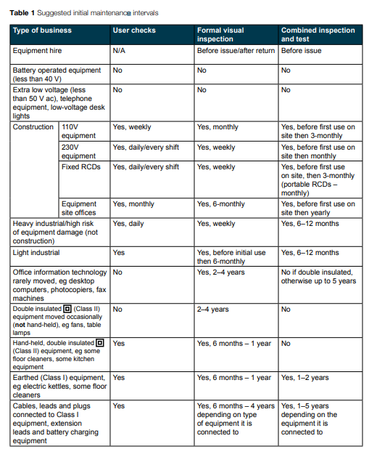

- Links to Guidance

Health & Safety Executive - Electrical Safety at Work - http://www.hse.gov.uk/electricity/index.htm

Maintaining portable electric equipment in low-risk environments - https://www.hse.gov.uk/pubns/indg236.htm

Electricity at Work Regulations 1989 - https://www.legislation.gov.uk/uksi/1989/635/regulation/2/made

- Review
These guidance and procedures will be reviewed on an annual basis.

Document approved by: H&S Policy Review Group

Last updated/reviewed: September 2024
Date issued:
Date of next review:

