  Request for a visit to re-rate your business | 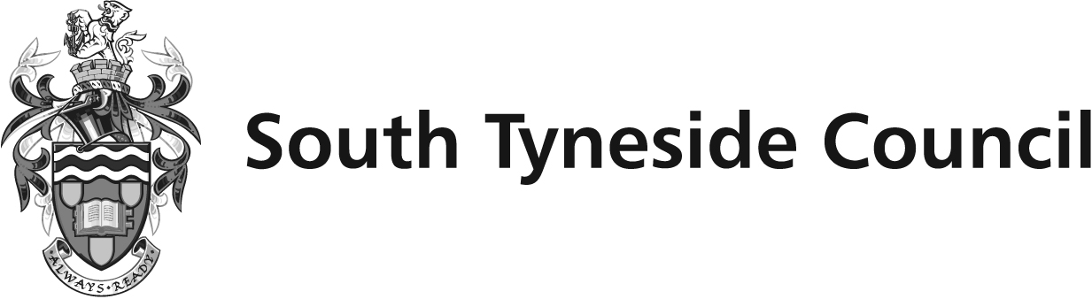 | 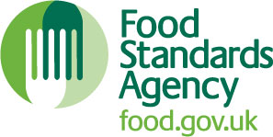

Please read all information carefully before applying

- As the food business operator of the establishment you have a right to request a re-visit for the purposes of re-rating if you have taken action to rectify the non-compliances identified at the time of inspection. There is a non-refundable charge of £208 (incl VAT) payable in advance for this service. The rerating visit will be unannounced and will be carried out within 3 months of receipt of payment
- You should try to provide as much evidence as you can to show that you have made improvements. Do not send payment with this application form. We will contact you to let you know if you have provided enough information and to arrange payment.
- There is no limit to the number of times you can request a re-rating. However, each visit costs £208 (from November 2024)
- If we fail to visit within 3 months of receipt of payment (and the delay is on the part of the Environmental Health service) we will refund your payment and make a free rerating visit.
- The food safety officer will give a food hygiene rating based on the level of compliance that is found at the time of the visit. Ratings can go up, down or remain the same.
- Any non-compliance found during the visit will be dealt with accordingly.
- To make a request for a re-rate, please complete this form and return it to the food safety officer from your local authority – contact details are provided with the written notification of your food hygiene rating.

Business details
Food business operator/proprietor

Business name

Business addresses | .

Business tel. number |  | Business email

Inspection details
Date of inspection |  |  |  |  | Food hygiene rating given at that inspection

Inspector’s Name

Action taken

Please describe the remedial action you have taken with reference to the issues identified in the inspection letter/report provided to you by your local authority with your score:

Compliance with food hygiene and safety procedures

Compliance with structural requirements

Confidence in management/control procedures

Please provide any other supplementary evidence (e.g. photographs, invoices, copies of relevant HACCP documentation etc.).

Please feel free to use a separate sheet of paper to provide further relevant details if required.

I agree to the payment of a non-refundable fee of £208 for a FHRS rerating visit and accept that my FHRS score can go up, down or remain the same at the rerating visit.

 |  | Signature
 |  | Name in Capitals
 |  | Position
 |  | Date |  |  |  | Phone no
 |  | Email

Please now return this form to:
Environmental Health, South Tyneside Council, Town Hall & Civic Offices, Westoe Road, South Shields, NE33 2RL or email environmentalh@southtyneside.gov.uk

Food Hygiene Rating Scheme (FHRS) Request for a Re-Rating Visit

We only rate your business at each inspection. We will only re-rate before your next inspection following a successful re-rate application and payment in advance. Please provide full details of improvements to support your application. At the re-rating visit we will carry out a full inspection and update your hygiene rating. You can apply anytime following the inspection. The visit will be unannounced and will occur within 3 months from receipt of payment. Alternatively you can wait until your next scheduled unannounced inspection.

